**API Integration Report - Furniro**

Brand Name: Furniro

Theme: A focus on modern, vibrant, and stylish furniture collections, emphasizing contemporary home decor.

API Integration:

Step1: API Endpoint Setup

* API Endpoint: https://template6-six.vercel.app/api/products
* Data Structure: The API provides product data, including fields like name, description, Product Image, price, Discount Percentage
* Library Used: Axios was used to fetch data from the API.

Step2: Fetch Data from API

Adjustment Made to Schemas:

Product Schema

import { defineType } from "sanity"

export const product = defineType({

name: "product",

title: "Product",

type: "document",

fields: [

{

name: "title",

title: "Title",

validation: (rule) => rule.required(),

type: "string"

},

{

name:"description",

type:"text",

validation: (rule) => rule.required(),

title:"Description",

},

{

name: "productImage",

type: "image",

validation: (rule) => rule.required(),

title: "Product Image"

},

{

name: "price",

type: "number",

validation: (rule) => rule.required(),

title: "Price",

},

{

name: "tags",

type: "array",

title: "Tags",

of: [{ type: "string" }]

},

{

name:"dicountPercentage",

type:"number",

title:"Discount Percentage",

},

{

name:"isNew",

type:"boolean",

title:"New Badge",

}

]

})

Migration Steps and Tool Used:

Migration Steps:

1. Environment Setup:

Installed required dependencies: @sanity/client, axios, dotenv.

Created a .env.local file to securely store environment variables.

1. Data Fetching:

Retrieved product data from the API endpoint using Axios.

Parsed and logged the data to confirm its structure and integrity.

1. Image Upload:

Downloaded images from the API's image field using Axios.

Uploaded the downloaded images to Sanity's Asset Manager using the Sanity client.

const buffer = await response.arrayBuffer();

const bufferImage = Buffer.from(buffer);

const asset = await client.assets.upload('image', bufferImage, {

filename: imageUrl.split('/').pop(),

});

4. Document Creation:

Created Sanity documents for each product by combining API data and uploaded image references.

Tool Used:

Sanity Client: For interacting with the Sanity CMS.

Screenshots

**API Call Output:**

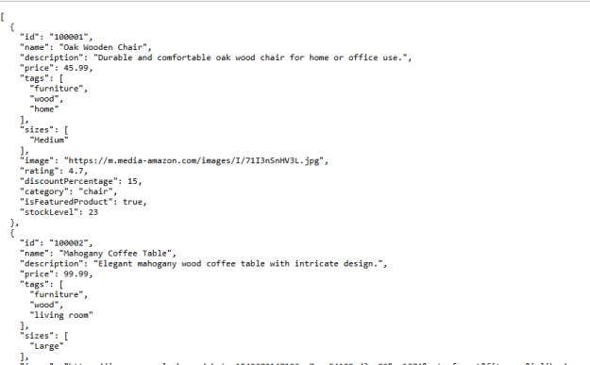

**Frontend Display:**

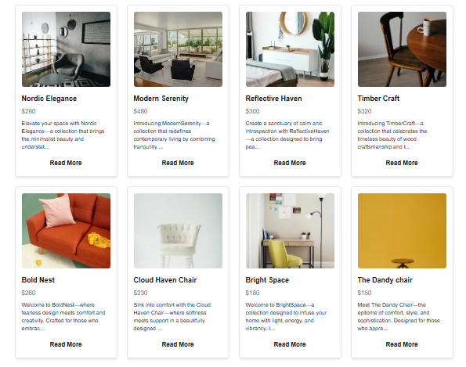

**Add to Cart Display:**

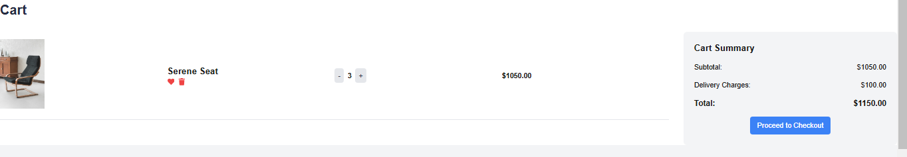

**Populated Sanity Field:**

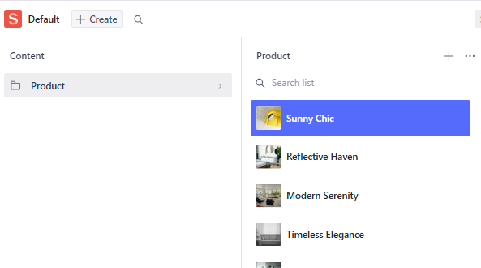

**Code Snippets:**

API Integration



Migration Script

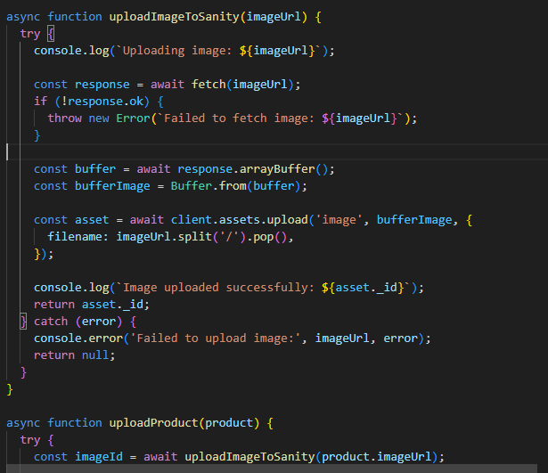

Final Check List:

* API Understanding
* Schema Validation
* Data Migration
* API Integration in Next.js
* Submission Preparation